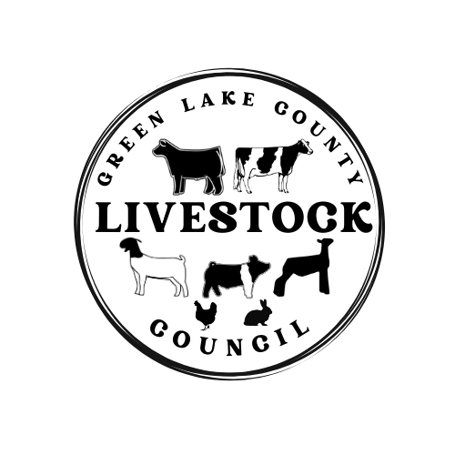
Green Lake County Livestock Council Meeting
Tuesday April 21st, 2026 @ 6:30pm
GLC Government Center

- Call meeting to order
- Pledges
- Action Item: Treasurers’ Report
- Action Item: Secretary’s Report
- Correspondence
- Meeting Business
- Announcement: Handbook amendment
- Announcement: Animal ID Form & Acknowledgment Forms- Due April 30th
- Announcement: Responsibility Sheet- May 1st
- Announcement: June meeting at MAC. Officer nominations: Vice President/Treasurer
- Announcement: Sheep Fitting Clinic
- Discussion: Fitting Rule Update
- Discussion: Crossing Scale Update from County/State
- Discussion: Livestock Council to move from 4-H

- Adjourn

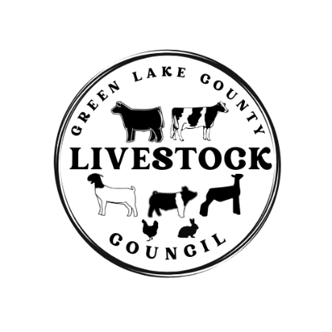
The Green Lake County Livestock Council meeting was called to order on Tuesday October 21st, 2025, at 6:30pm by President Dan Huitema. The pledges were done, the treasurers’ report was sent to audit, and the sectary’s report was approved.

There was an announcement of Vice President change, Kelsey Lenz resigned and Lisa Reyes was appointed Vice President by President Dan Huitema. The 2025 Green Lake County Fair Auction results were shared.

The 2025/2026 handbook was reviewed highlighting changes. There was the request to add in the mouth diagram for the steers. The handbook was then voted on and approved. The 2025/2026 Livestock Council Budget was then reviewed. The Livestock Council will pay for the scales for the 2026 fair and not pay for the judges. For 2026 there will have to be commissions taken out of exhibitor’s auction checks as well. This will be a flat fee of $60 per lot instead of a percentage. This will continue to be reviewed on an annual basis. The budget was then voted on and approved.

Discussion was had on letting people cross the scale multiple times before the official weigh in at the fair. The discussion was tabled, and Miranda is to reach out to surrounding counties to compare what other practices are. Discussion was had on removing the fitting rule from the Livestock Handbook, this was tabled. Discussion to end purchasing champion buyer’s gifts and run more advertising showcasing the buyers instead. This was put to a motion, voted on and approved.

The next meeting will be January 20th, 2026, at the Green Lake Government Center. This will be an educational meeting with a guest speaker. Meeting was adjourned.

Respectfully submitted by,
Miranda Huitema
GLC Livestock Council Secretary

