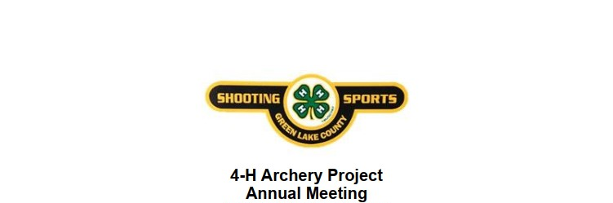
11 Dec. 2025 7 PM
Green Lake County Government Center _Training Room

- Pledges
- Review of constitution and Bylaws
- Treasurer’s report
- Election of Officers
- President (2-year Term even year election) Matt Austin Standing President was elected 1 Oct 2024
- Vice President (2 -Year Term odd year election per project Bylaws) Clint Wendt Standing VP was elected 1 Oct 2024 (odd year election)
- Secretary (2-year term odd year election) Standing Secretary Tom Zulke was elected 1 Oct 2024
- Treasurer (2-year Term even year election) Andrew Reyes Standing Treasurer was elected 1 Oct 2024
- Adult Representative (1 year term) Jennifer Standing Adult Representative
- Youth Representatives (1 year Term) Sophia Standing Youth Representative
- Youth Representative (1 year Term) Sam Austin standing Youth Representative
- Youth Representative (1 year Term) Ethan Wendt standing Youth Representative

- Discussion of Budget…Need a vote on Waiving shooting fees again. Do we want to repair or replace arrow supply?
- Review of Operations from 2025
- Goals for 2026
- Discussion of summer shooting dates and availability of Horse Arena
- Next meeting date
- adjournment

