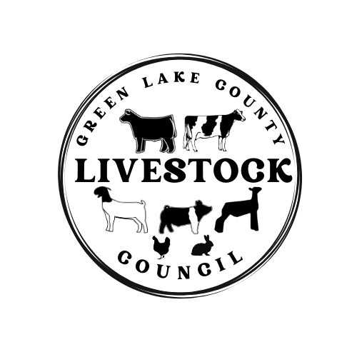
Green Lake County Livestock Council Meeting
Tuesday June 18th 2024 @ 6:30pm
MAC Center

- Call meeting to order
- Pledges
- Treasurers’ Report
- Secretary’s Report
- Correspondence
- Meeting Business
- Lamb Donation or Sponsorship for Buyer’s Dinner (Adam’s Rib)
- Gates/Auction Location-UPDATE
- Dairy Show Clinic-July 9th @ 6:30 pm Bruss Family Farm
- Swine Show Clinic-June 19th @ 6:30pm Newton’s Farm
- Reminder-YQCA July 1st
- Fairy Entries Due July 1st
- Responsibility Sheet-Confirm/New Family Sign Up-Due June 18th
- Officer Nominations: Vice President, Treasurer, and Two youth reps
- Election Process
- Adjourn

