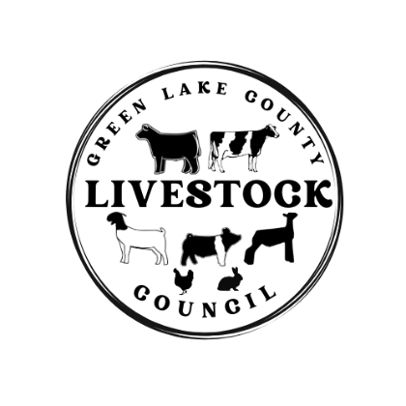
The Green Lake County Livestock Council meeting was called to order on Tuesday January 16th, 2024, at 6:30pm by President Dan Huitema in the training room at the GLC Government Center. The pledges were done, the treasurers’ report was sent to audit, and the secretary’s report was approved.
Meeting business included budget approval for the Livestock Council 2024 budget. Kaylee made a motion to approve the budget and Lilly seconded the motion. The budget was approved. There was an announcement that the ear tag sign up was open and due by March 1st, 2024.
There was a request for a donation to the UWRF Block and Bridle Prospect Weekend. Gavin made a motion to donate $100 and Kelsey seconded the motion. The donation was made. The announcement that the sheep rate of gain contest was coming back to the fair this year. The council went over some of the handbook highlights as a reminder, including no selling at other fairs went into effect this year.
Discussion was made about getting gates to replace the snow fence. There were a lot of good options brought up including, purchasing our own gates, renting gates from other fairs, where to store the gates, and if we should move the auction location. The council decided to table this discussion.
Lilly made a motion to adjourn the meeting and Brianna seconded the motion.
The next Livestock Council Meeting is April 16th, 2024, at 6:30pm in the Training Room at the GLC Government Center.

Respectfully submitted by,
Miranda Huitema
Livestock Council Secretary

