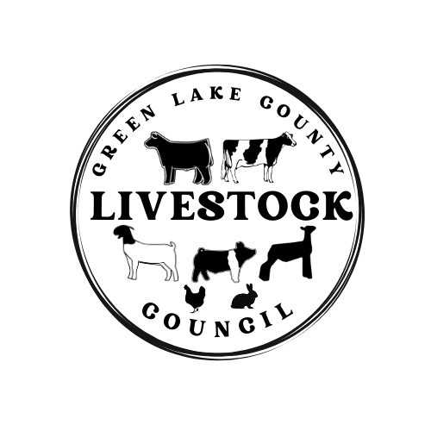
The Green Lake County Livestock Council Meeting was called to order on Tuesday October 17, 2023 at 6:30pm by President Dan Huitema. Pledges were done, treasurer’s report was sent to audit, there was a correction on the secretary’s report to fix the youth rep to Kaleb, and there was one correspondence read.

Meeting business there was an auction recap. Along with the announcement of the auction results the Livestock Committee announced that they would increase their 2024 scholarship to match the funds that were raised. A sheep/swine barn air movement committee was purposed and the Newton Family said they would look into options for that barn.

The 2024 Livestock Council Handbook was reviewed and took to a vote for approval. Amy Newton made a motion to approve and Jodi Mace seconded the motion. The motioned passed and the handbook was approved. The livestock council proposed switching bank accounts to Ergo Bank. Chumly made a motion to approve the move and Beth M. seconded the motion. The motion passed and the bank account will be switched to Ergo bank.

Jodi Mace brought up a concern about the dairy barn electrical box. Stacy G. said that the county is aware and they are working on it.

Kelsey made a motion to adjourn the meeting and it was seconded by Andrew T. meeting was adjourned.

Next Meeting is January 17, 2024 @ 6:30pm Training Room GLC Gov. Center

Respectfully submitted by,
Miranda Huitema
Livestock Council Secretary

